

EXPERIMENT - 3

Switching Theory and Logic Design (STLD)

Aim

To verify the truth tables of all logical gates(AND, OR, NOT, NAND, NOR,

XOR, XNOR) using NOR gate only.

Syeda Reeha Quasar

14114802719

3C7

# EXPERIMENT - 3

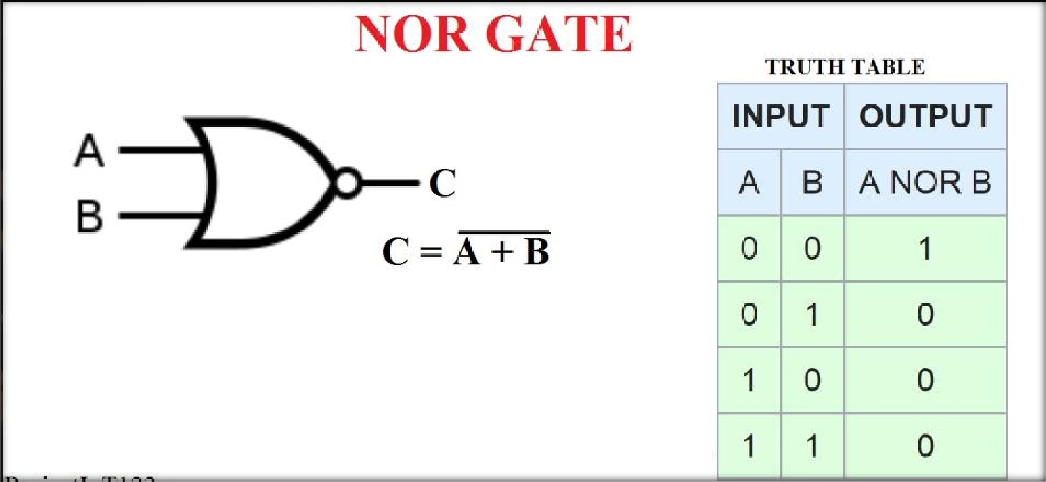

## AIM:

To verify the truth tables of all logical gates (AND, OR, NOT, NAND, NOR, XOR, XNOR) using NOR gate only.

## Hardware and Software Apparatus Required

### Hardware:

* Power supply, Bread Board, Connecting Wires, respective IC, LED, Wire Cutter.
* Circuit is designed on bread board using Integrated Chips (ICs), Voltage supply and LEDS.
* The set-up of apparatus and working of the circuit were demonstrated via recorded videos.

### Software Simulation:

The schematic models of the desired circuits will be stimulated on MULTISIM (Free Software), easily accessible at [www.multisim.com](http://www.multisim.com/).

Components used – Source (Clock Voltage), Passive elements (resistor), Digital components (AND, OR, NAND, NOR, XOR, XNOR, Inverter), Probe for Analysis and annotation (Digital), Schematic connectors (Ground)

## Theory:

Circuit Symbol and Truth table:

***Pin Diagram:***

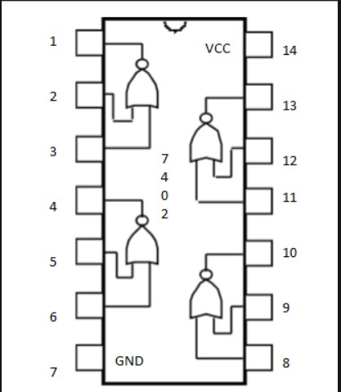

**NOR gate:**

The NOR gate is a digital logic gate that implements logical NOR - it behaves according to the truth table to the right. A HIGH output (1) results if both the inputs to the gate are LOW (0); if one or both input is HIGH (1), a LOW output (0) results.

NOR is the result of the negation of the OR operator. It can also in some senses be seen as the inverse of an AND gate. NOR is a functionally complete operation—NOR gates can be combined to generate any other logical function. It shares this property with the NAND gate. By contrast, the OR operator is monotonic as it can only change LOW to HIGH but not vice versa.

## Procedure followed on MULTISIM:

1. LOG IN ON [www.multisim.com](http://www.multisim.com/)
2. CREATE THE CIRCUIT
3. SAVE THE CIRCUIT
4. SAVE THE SCREENSHOTS FOR
   1. INPUT & OUTPUT WAVEFORMS (ALONG WITH YOUR ID ON TOP LEFT)
   2. CIRCUIT (ALONG WITH YOUR ID ON TOP LEFT)

# Screenshot of circuit: NOT(Inverter) using NOR

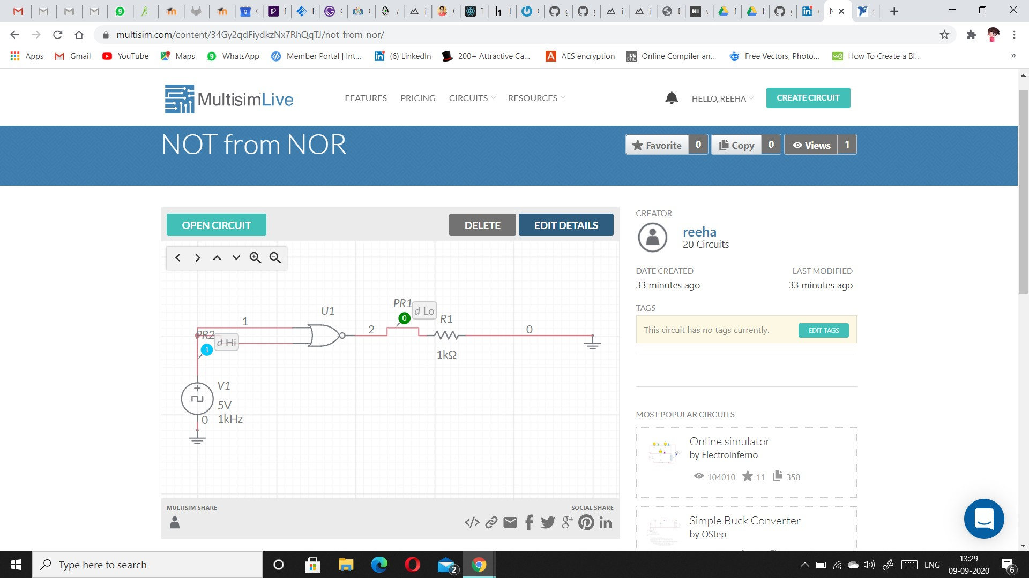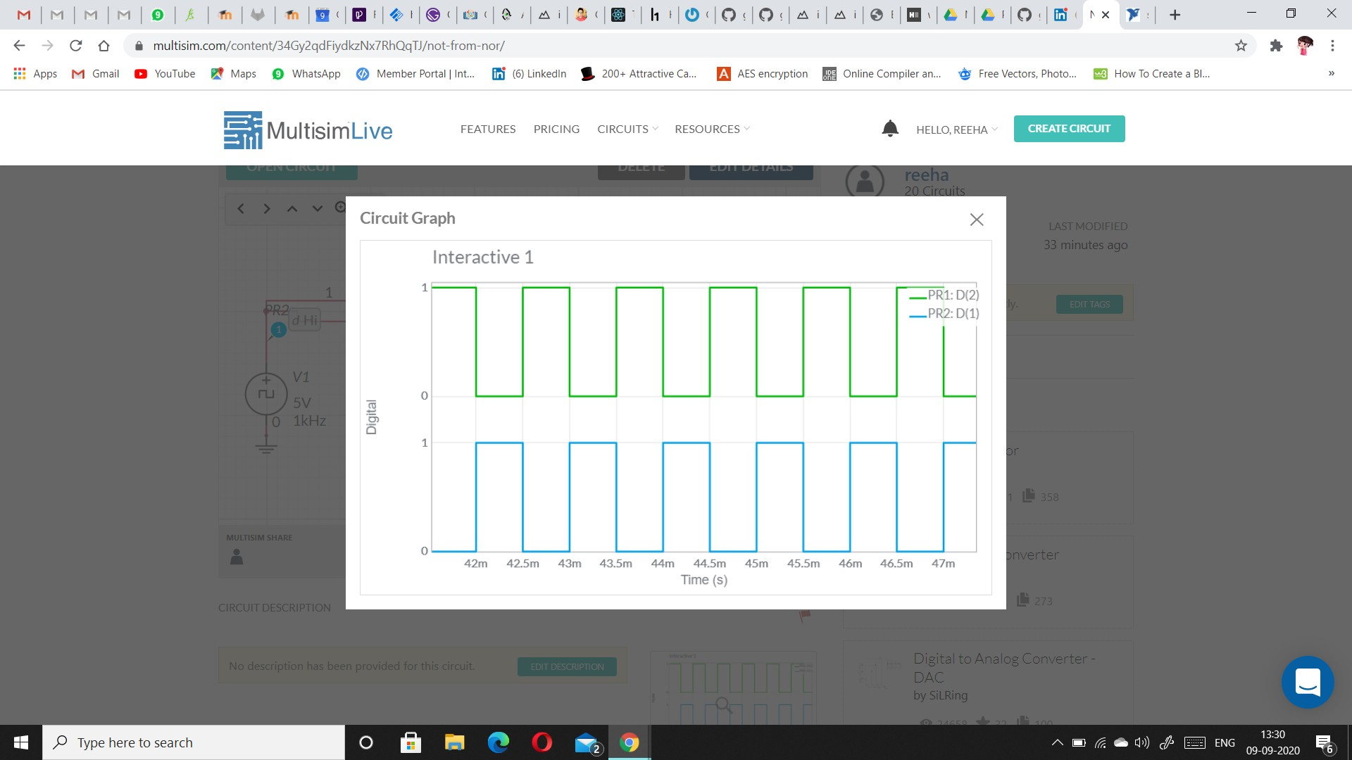

**Screenshot of circuit: AND using NOR**

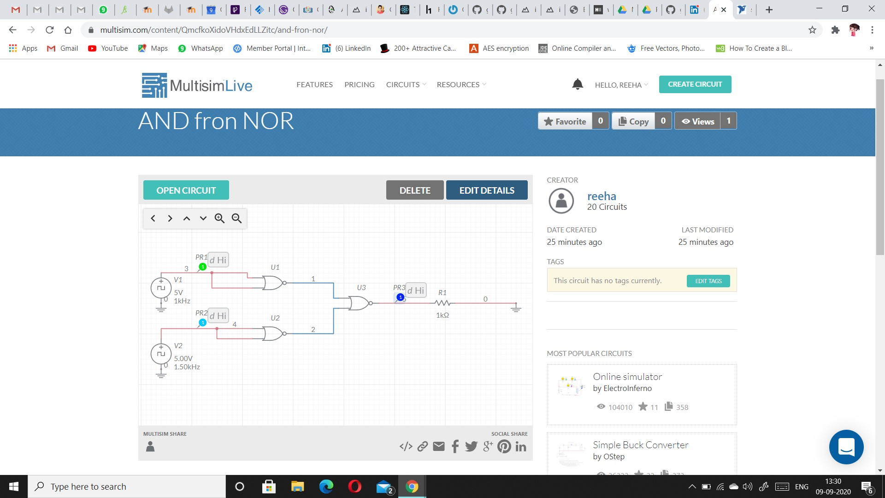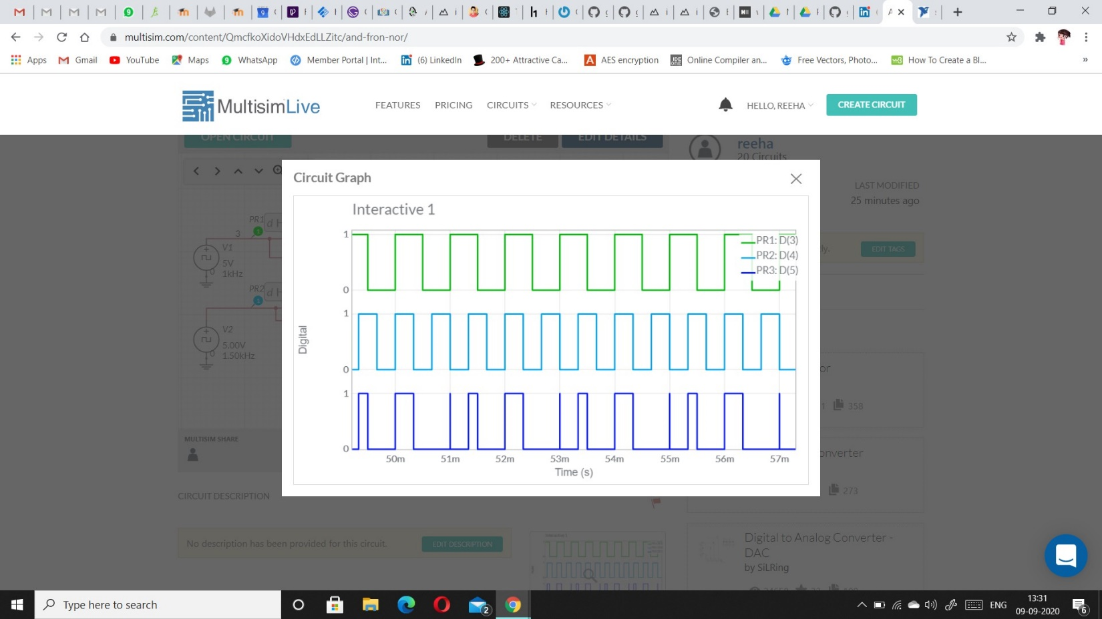

**Screenshot of circuit: OR using NOR**

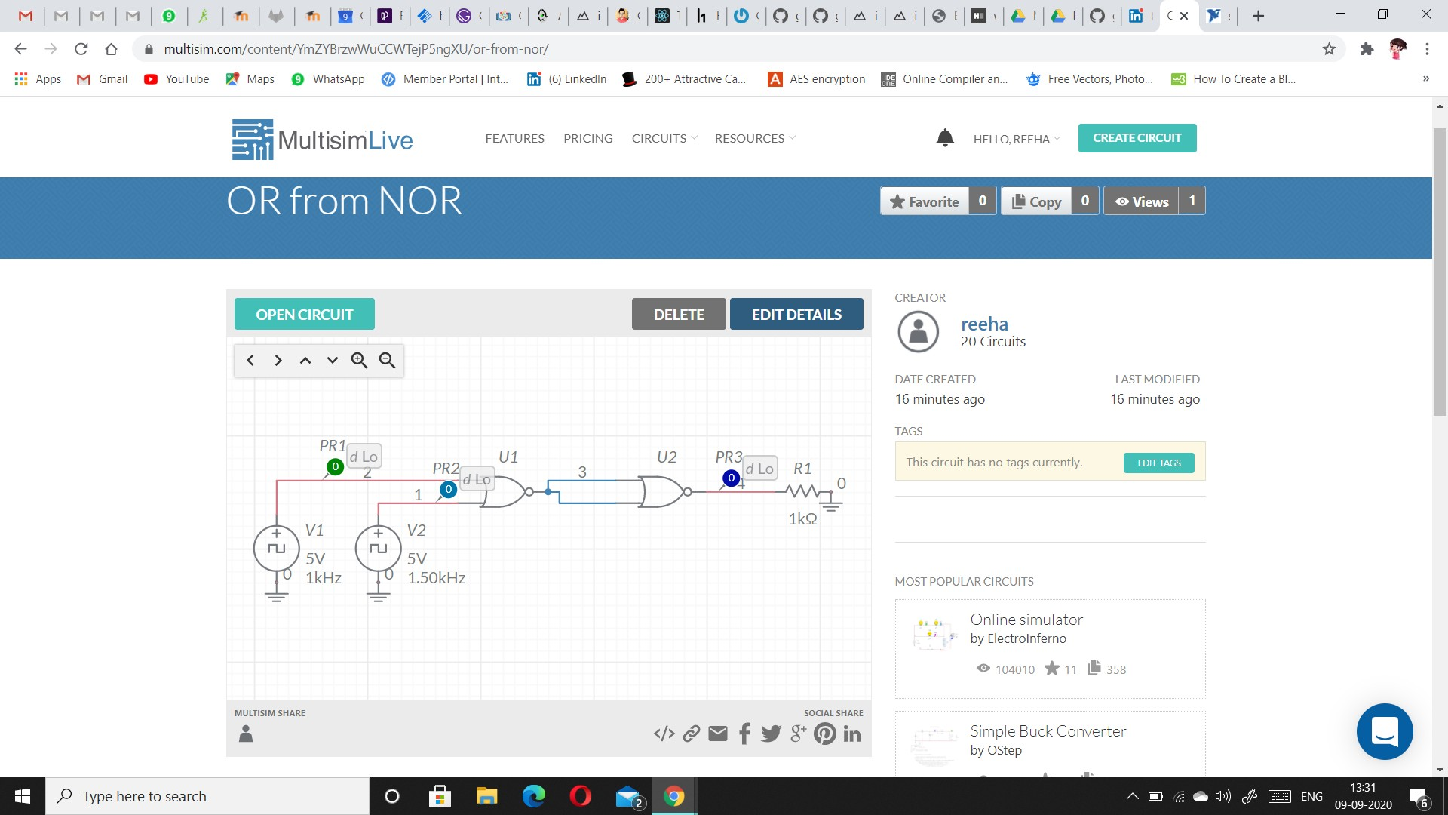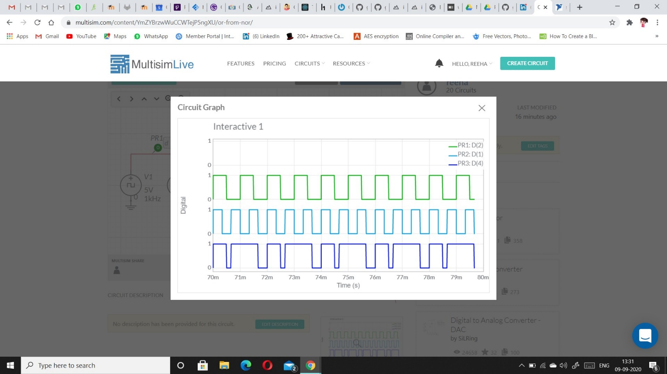

**Screenshot of circuit: NAND using NOR**

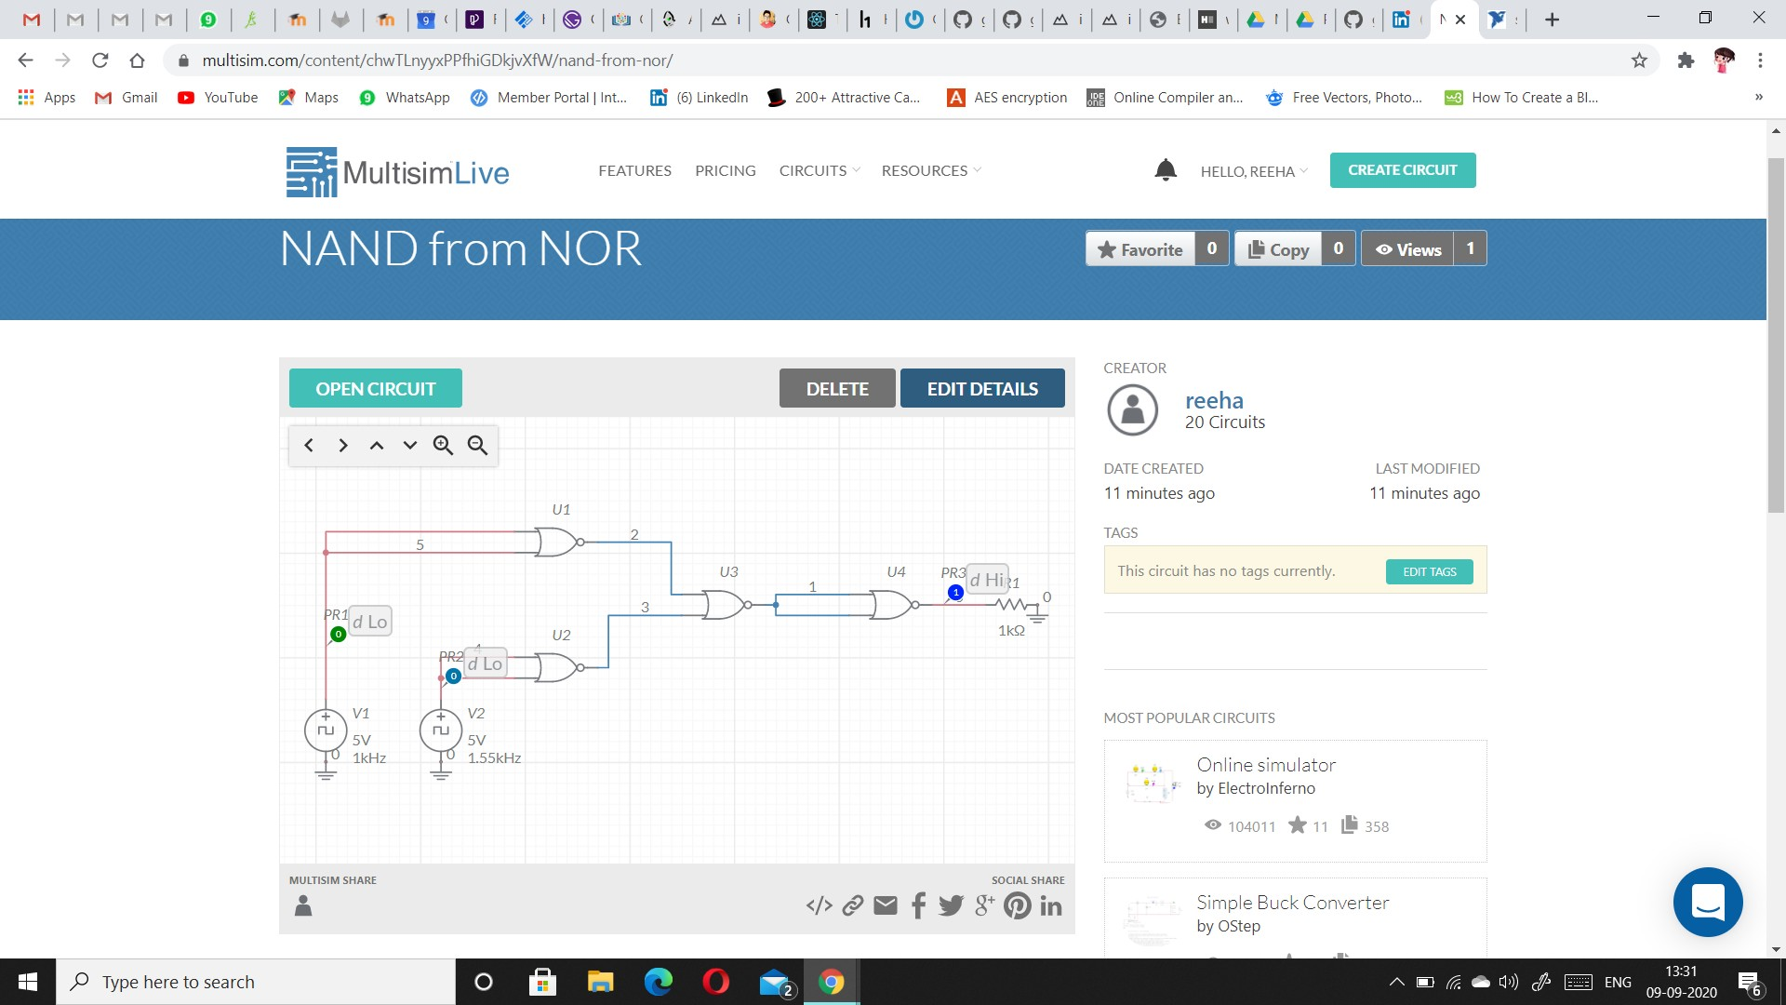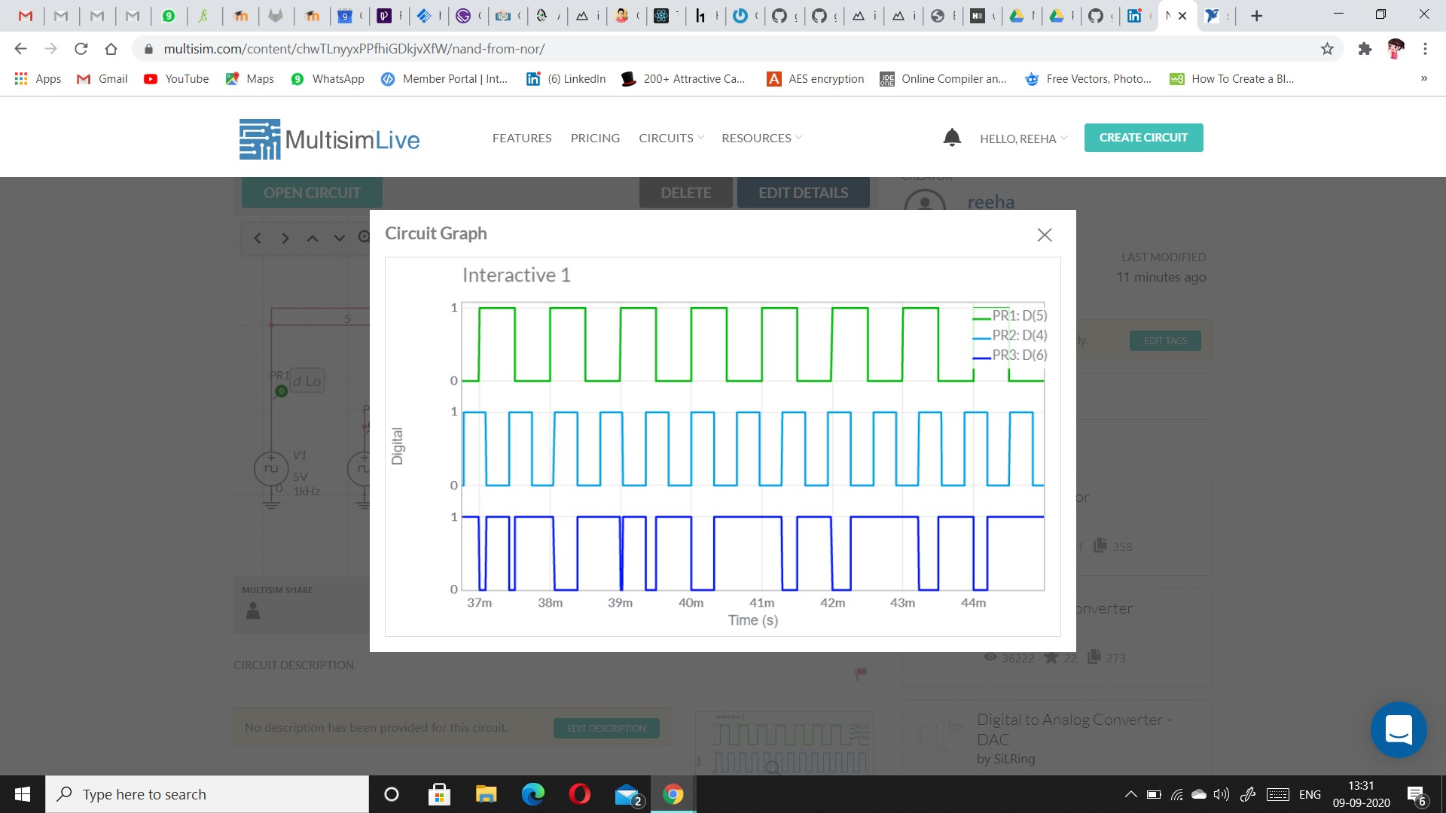

**Screenshot of circuit: XOR using NOR**

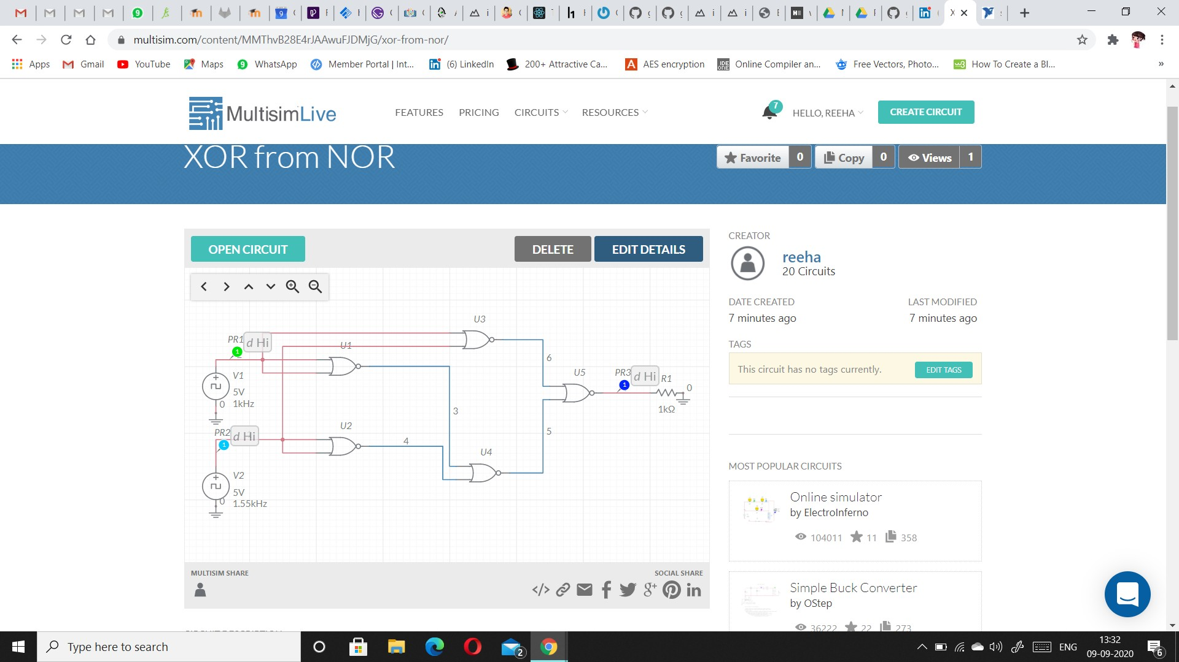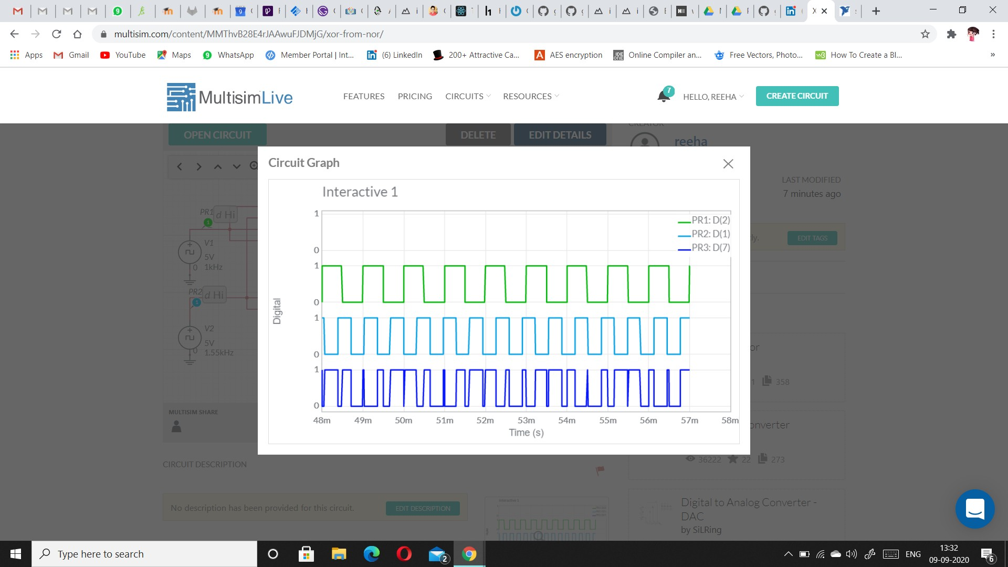



**Screenshot of circuit: XNOR using NOR**

# Result:

All gates has been verified

# Viva Questions

1. **A logic circuit that provides a HIGH output for both inputs HIGH or both inputs LOW is a(n):**
2. **Ex-NOR gate**
3. **OR gate**
4. **Ex-OR gate**
5. **NAND gate**

ANS.

Option **A**

1. **How many two-input AND and OR gates are required to realize Y = CD+EF+G?  
   a) 2, 2  
   b) 2, 3  
   c) 3, 3  
   d) 3, 2**

Ans.

Answer: a  
Explanation: Y = CD + EF + G  
The number of two input AND gate = 2  
The number of two input OR gate = 2.

1. **Which of following are known as universal gates?  
   a) NAND & NOR  
   b) AND & OR  
   c) XOR & OR  
   d) EX-NOR & XOR**

Ans.

Answer: a  
Explanation: The NAND & NOR gates are known as universal gates because any digital circuit can be realized completely by using either of these two gates, and also they can generate the 3 basic gates AND, OR and NOT.

1. **A single transistor can be used to build which of the following digital logic gates?**

**A. AND gates**

**B. OR gates**

**C. NOT gates**

**D. NAND gates**

Ans.

C) Or Gates